**Procedimientos**

1.

DELIMITER //

MariaDB [colegio]> CREATE PROCEDURE totalestudiante()

-> BEGIN

-> SELECT semestre, COUNT(*) AS TOTAL FROM estudiante GROUP BY semestre;

-> END

-> //

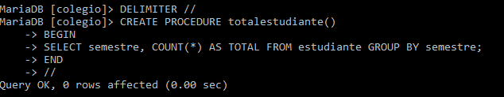

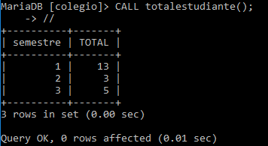

2.

CREATE PROCEDURE listaestudiante(sem INT)

-> SELECT codigo, nombre, apellido, email FROM estudiante WHERE semestre=sem;

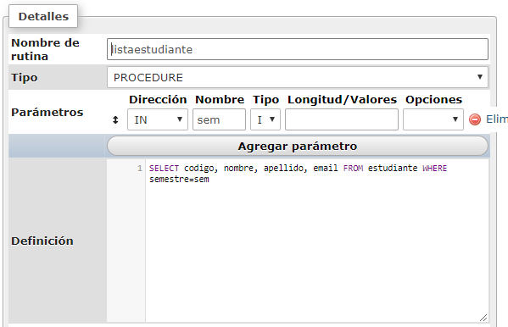

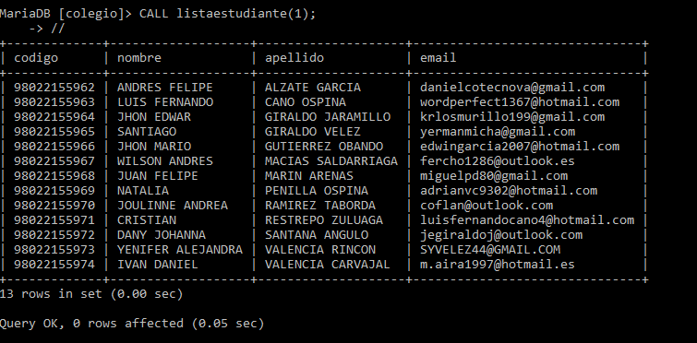

3.

CREATE PROCEDURE email_estudiante(code BIGINT)

-> SELECT email FROM estudiante WHERE codigo=code;

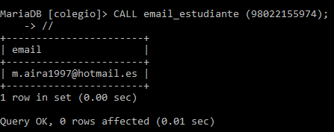

4.

CREATE PROCEDURE gmail_hotmail (correo VARCHAR(10))

-> BEGIN

-> SELECT nombre, email FROM estudiante WHERE email LIKE CONCAT('%',correo,'%');

-> END;

-> //

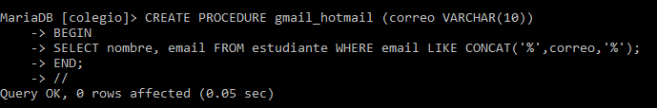

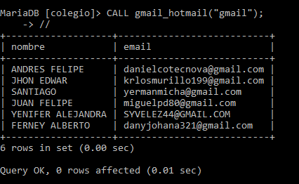

5.

DELIMITER //

CREATE PROCEDURE est_list (valor INT)

BEGIN

IF valor=1 THEN

SELECT *FROM estudiante ORDER BY nombre DESC;

ELSE

SELECT *FROM estudiante ORDER BY nombre ASC;

END IF;

END

//

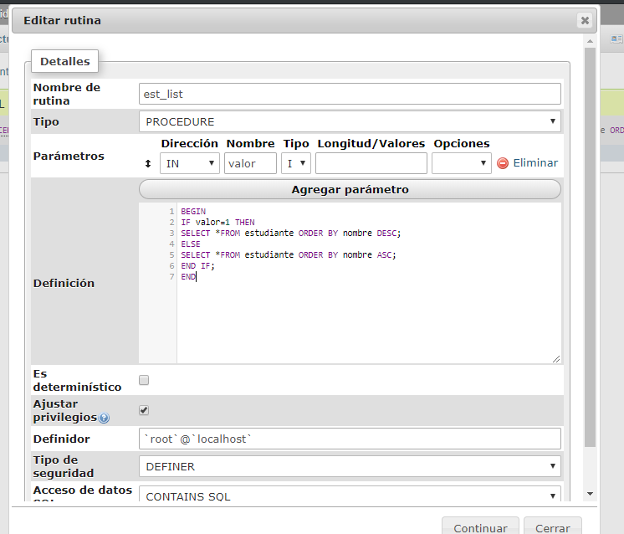

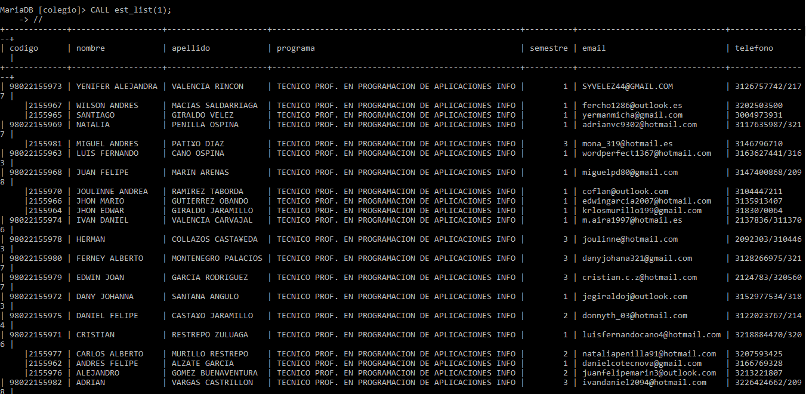

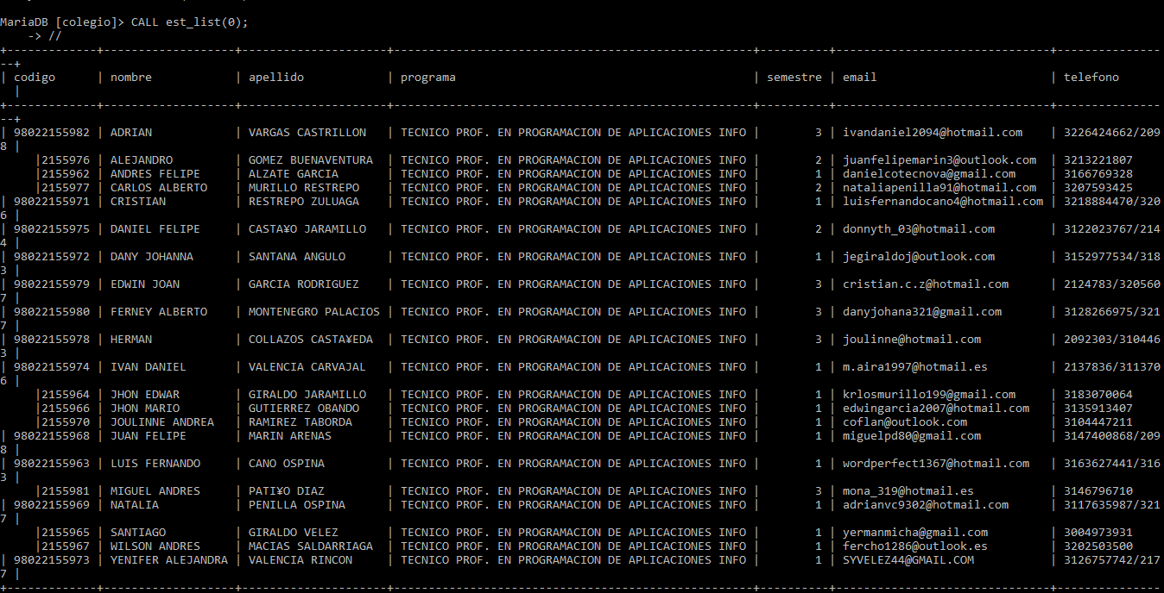

**Funciones:**

1.

DELIMITER $$

MariaDB [colegio]> CREATE FUNCTION estudent_total ()

-> RETURNS INT

-> BEGIN

-> RETURN (SELECT COUNT(*) FROM estudiante);

-> END

-> $$

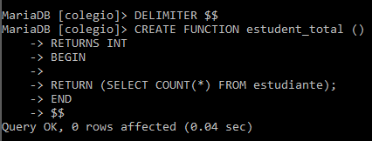

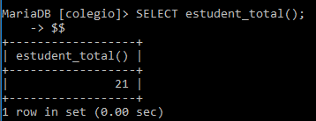

2.

CREATE FUNCTION programa_est (code BIGINT)

-> RETURNS TEXT

-> BEGIN

-> RETURN (SELECT programa FROM estudiante WHERE codigo=code);

-> END

-> $$

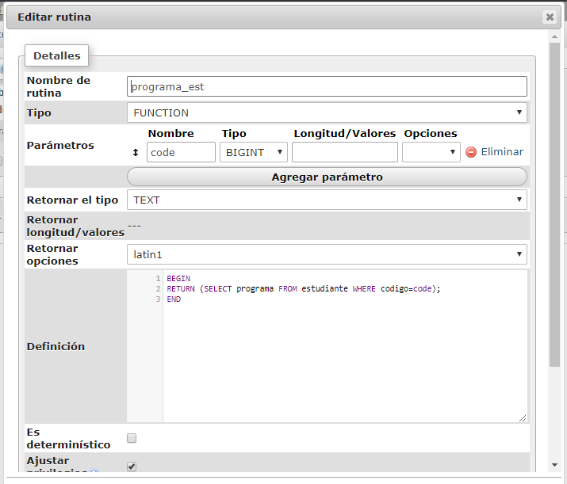

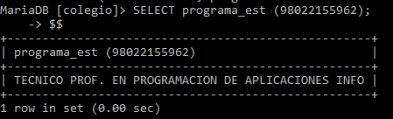

3.

DELIMITER $$

MariaDB [colegio]> CREATE FUNCTION correos (correo VARCHAR(10))

-> RETURNS INT

-> BEGIN

-> RETURN (SELECT COUNT(*) FROM estudiante WHERE email LIKE CONCAT('%',correo,'%'));

-> END

-> $$

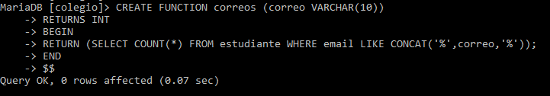

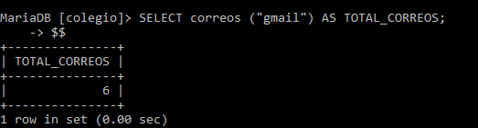

4.

DELIMITER $$

MariaDB [colegio]> CREATE FUNCTION correo_est (correo VARCHAR(50))

-> RETURNS TEXT

-> BEGIN

-> RETURN (SELECT nombre FROM estudiante WHERE email=correo);

-> END

-> $$

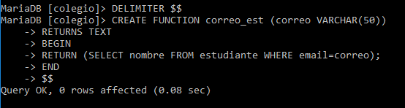

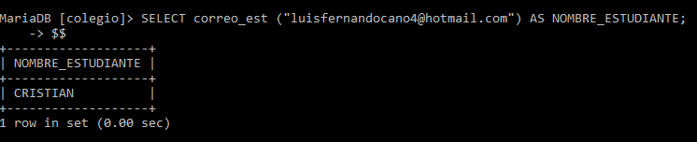

5.

DELIMITER $$

MariaDB [colegio]> CREATE FUNCTION cantidad_estudiante_semestre (sem INT)

-> RETURNS INT

-> BEGIN

-> RETURN (SELECT COUNT(*) FROM estudiante WHERE semestre=sem);

-> END

-> $$

